NAME:NAVODITAA A.R
ROLL NO.:241901071

Exercise 10

DESIGN A SIMPLE TOPOLOGY AND CONFIGURE WITH ONE ROUTER, TWO
SWITCHES AND PCS USING CISCO PACKET TRACER
Aim:
To design and configure a simple network topology using one router, two switches, and PCs in Cisco Packet Tracer and verify successful communication between networks.
Introduction:
In networking, routers are used to connect multiple networks.
Switches connect devices within a single LAN.
In this experiment, two LANs (connected by switches) are linked using a router.
Each LAN will have its own IP network, and the router will route packets between them.
Algorithm:
- Start Cisco Packet Tracer.
- Select and place devices:
- 1 Router (e.g., Cisco 2911)
- 2 Switches (e.g., 2960)
- 4 PCs
- Connect the devices using Copper Straight-Through cables:
- PC0 → Switch0 (F0/1)
- PC1 → Switch0 (F0/2)
- PC2 → Switch1 (F0/1)
- PC3 → Switch1 (F0/2)
- Switch0 → Router (G0/0)
- Switch1 → Router (G0/1)
- Assign IP addresses to PCs:
- LAN1 → 192.168.1.0/24 (PC0, PC1)
- LAN2 → 192.168.2.0/24 (PC2, PC3)
- Configure router interfaces:
- Interface G0/0 → 192.168.1.1 255.255.255.0
- Interface G0/1 → 192.168.2.1 255.255.255.0
- Use no shutdown command to activate interfaces.
- Set Default Gateway on each PC:
- For PCs in LAN1 → 192.168.1.1
- For PCs in LAN2 → 192.168.2.1
- Verify connections:
- Use the ping command from one PC in LAN1 to a PC in LAN2.
- Check for successful replies.
- Stop.
- If packets are successfully received, the topology is working correctly.
NetworTopology: 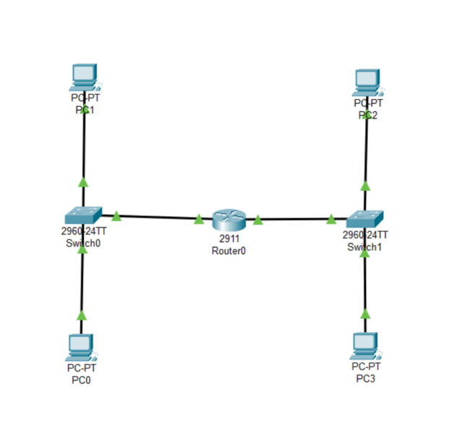
Output:
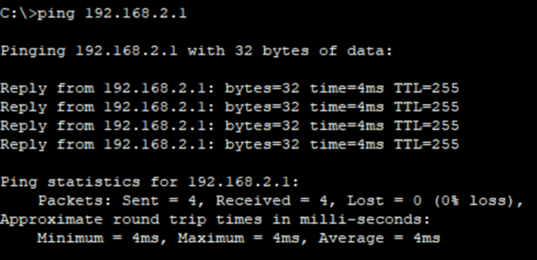
Result:
A simple network topology using one router, two switches, and multiple PCs was designed and configured successfully in Cisco Packet Tracer. Communication between both networks was verified using the ping command.

